A Play Script Influenced by Raven: A Trickster Tale from The Pacific Northwest
Told and illustrated by Gerald McDermott
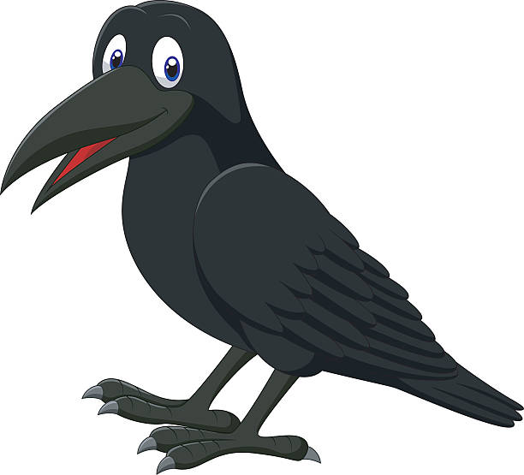

CAST
The Roles:
Narrator 1
Narrator 2
Narrator 3
Narrator 4
Narrator 5
Raven
Sky Chief
Sky Chief’s daughter
Elder
Raven-child
It’s Showtime!
Before the play begins, hit the lights to help the audience and play members visualize “the darkness”.

-narrators standing on the side of the stage-
-raven enters-

Narrator 1: The world was in darkness.
The sky was in darkness.
The waters were in darkness.
Men and women lived in the dark and cold.

Narrator 2: Raven felt their sadness.

Raven: I have an idea!
I will search for light!

Narrator 2: Raven flew over enormous mountains and across deep valleys.
He flew over lakes and rivers.
Darkness was everywhere.

Narrator 3: Raven saw a bit of light far away.
As Raven flew, he got closer to the light.
The light was by the water.

Narrator 4: The shining light came from Sky Chief’s house!
Raven flew high to the top of a pine tree.
Raven watched the Chief’s house.
-Chief’s Daughter enters-

Narrator 5: Raven saw a beautiful woman walk out of the shining house.
The woman went to the shore where she knelt, dipped her woven basket in the water, and took a drink.
She was the Sky Chief’s daughter!

Raven: I must get into this house to see what that light is.
I will play a trick on them!

Narrator 1: Raven had an idea!
He turned his body into a pine needle.
He dropped into the water.

-Raven exits-

Sky Chief’s daughter: I am so thirsty.

Narrator 2: When the woman drank more water, she swallowed the pine needle!
The woman did not know that she had swallowed anything.
She didn’t suspect that anyone was trying to trick her.

-Chief enters-

Narrator 3: As time passed, the woman’s belly grew.
One day, she gave birth to a child.
-Raven-Child enters-

Raven-child: Ga Ga.
Goo Goo
Ga Ga

Narrator 4: The child was very small with black hair and black eyes.
Do you know who the child was?
It was Raven!
Raven was reborn as a boy child.

Sky Chief: Oh, my grandchild!
I love you.

Narrator 3: The grandfather was very proud of the baby.
He asked the elder to come see him.

-Elder enters-

Elder: Wow. He is big.

Narrator 4: The child crawled around the house, but he was not playing.
He was looking for the light.

Narrator 5: Raven-child noticed a bentwood box in the corner of the house!
The box was enormous with a variety of carvings on the side.
The box was painted with red and black, and it was glowing!
Does anybody know how this box is glowing?
The sun was inside!

Raven-child: Ma ma! Pa Pa!

Sky Chief’s daughter: Yes, dear child? How can I help you?

Sky Chief: What does my good grandbaby want?

Raven-child: Ma Ma
Pa Pa
Wa Wa Wa Wa

Elder: He wants the box.

Sky Chief: If my grandchild wants the box,
Please give him the box!

Sky Chief’s daughter: Here, my child. Father says you can play with the box.

Raven-child: Ma ma.
Wa wa

Sky Chief: Open it for him!

-Chief’s daughter opening first 2 boxes-

Narrator 1: Raven-child’s mother took the lid off the large box.
There was smaller box was inside.
She took the lid off that box.
There was a tiny box inside.

Raven-child: Goo Goo
Ga Ga

-Chief’s daughter opening last box-

Narrator 5: Raven child’s beautiful mother took the lid off that last box.
Suddenly, bright light fell out of it!
The light poured into the room and surrounded the three generations in the room, as well as the elder.

Narrator 2: The abundance of light was coming from a ball inside of the box.
Do you all know what the ball was?
The ball was the sun!

Sky Chief’s daughter: Can he play with this ball?

Sky Chief: Yes! I love my grandson.

-Chief’s daughter hands ball to child-

Raven-child: Ya! Ya! Ya! Ya!

Narrator 3: Raven-child quickly turned into a bird!
He became Raven again!

Raven-Child: Ca! Ca!

-Raven-Child exists, Raven enters-

Raven: Caw! Caw!

Narrator 4: Sky Chief, Sky Chief’s daughter, and the elder were shocked.

Raven: You are greedy for keeping the sun all for yourself.
You must share it with the world.

Narrator 4: Raven took the sun in his beak.
He flew out of the house and threw it up into the sky.
-Chief’s daughter exit-
-Chief exit-
-Elder exit-

Narrator 5: The world that had forever been in darkness burst into light.
The people and the animals could finally see the sun for the first time.
They were excited and thankful.
This is the story of how Raven stole the sun for the people.

Narrator 1: Thank you Raven.

Raven: Caw! Caw! Caw!

End of Play

Thank you, students, for your hard work, bravery, and enthusiasm throughout this performance.

